**CHAPTER 4**

**RESULTS**

**4.1. Results**

The Algorithms contain different Image Operations each Image Operation gives out a result. The following chapter focuses on results of the operations done on each part of the project and the final result obtained from these operations. The final result is displayed in the GUI.

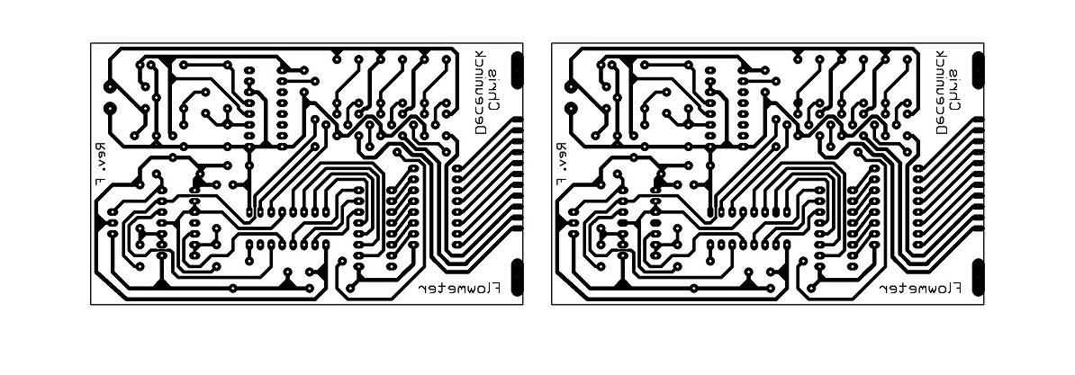

Figure 4.1 Registered output Image

The above Image is the result of registration that takes place in the first pace of the operation.The two images are seen in a montage which help us find the registration has been succesful or not.

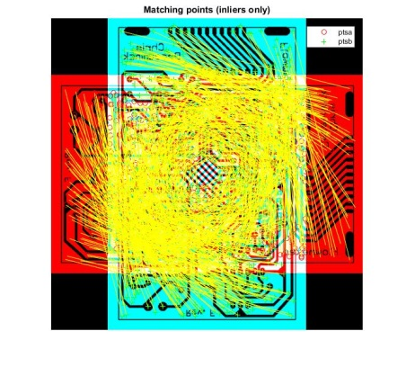

Figure 4.2 Matched points in Rotation of Images

The image shows matched points which are used for registration in case of rotated images.The template image is 900 rotated so the points are matched and the angle is recovered which gives us aligned images which help in further operations.

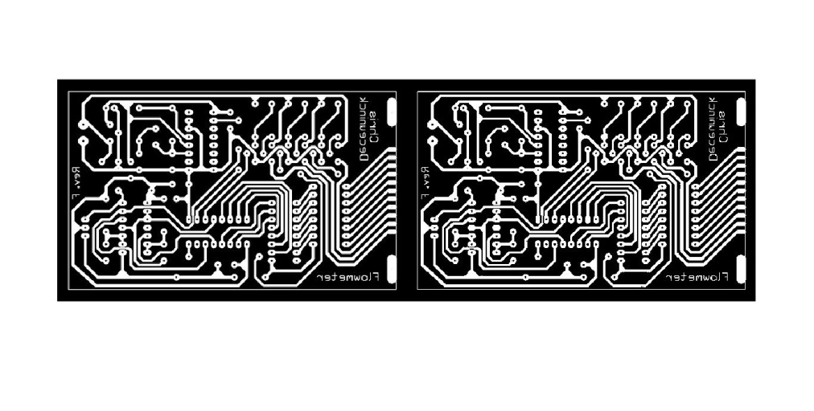

Figure 4.3 Complimented and Thresholded output

The above image is result of Thresholding and Image compliment both defective and template image is been operated and would be further subtracted

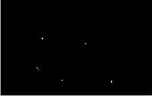

Figure 4.4 Image Subtraction Output

The above image is result of image subtraction of the template and defective PCB Image. The white spots on the Image depict that some defect is present in the Image over-etch or under-etch.The location of these pixels is taken for pixel manipulation operation and based on this the output is decided whether under-etch or over-etch.

The following results have been obtained out of the operations done over the images. The GUI has been programmed to help the user guide through the process of defect classification and detection.

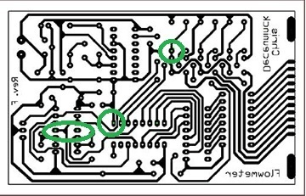

Figure 4.5 Results for Over-Etched

The above figure shows an over etched PCB. In an over etched PCB an extra layer of copper is present which may cause the components in the circuit to get damaged or give inappropriate results or reduce the circuit efficiency. In an over etched PCB the main defects could be further classified as Missing pinholes and Short circuit.

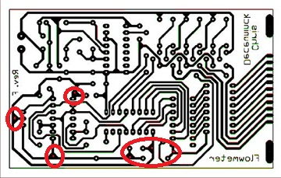

Figure 4.6 Result for under etched PCB

The above figure shows an under etched PCB. In an under etched PCB the layer of copper required is missing from its position. This may cause the components in the circuit to get damaged or give inappropriate results or reduce the circuit efficiency. In an under etched PCB the main defects could be further classified as Extra pinholes and Open circuit.

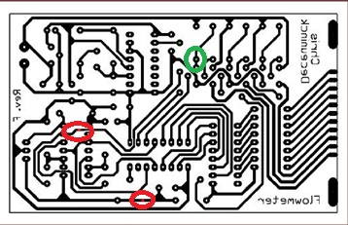

Figure 4.7 Result for under-etched and over-etched PCB

Above Figure shows a PCB having both the defects i.e. under–etched and over-etched. The green circles show over-etched defects and the red circles show under etched defects